**Lesson10 Azure Storage Access Tiers**

**Notes: -**

**1-by default each access tiers of the storage account will reflect to all containers and blobs that inherit this access tiers by default**

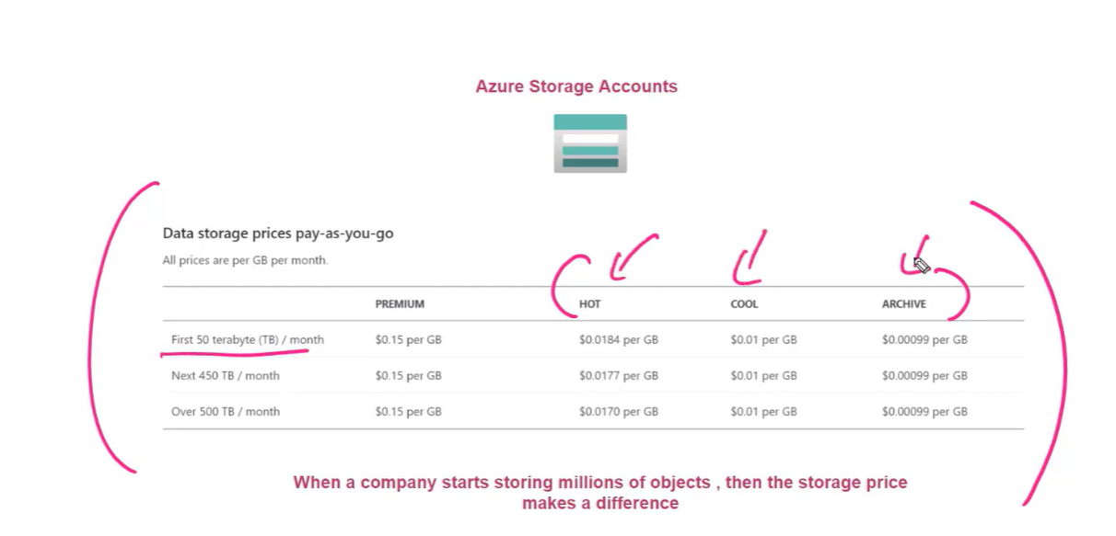

**You can select the hot / cool access tier when you try to create storage account**

**(While archive tier can be detect on each blob level not on container / storage level)**

**2-you can see that access tier appear on the storage account as below**

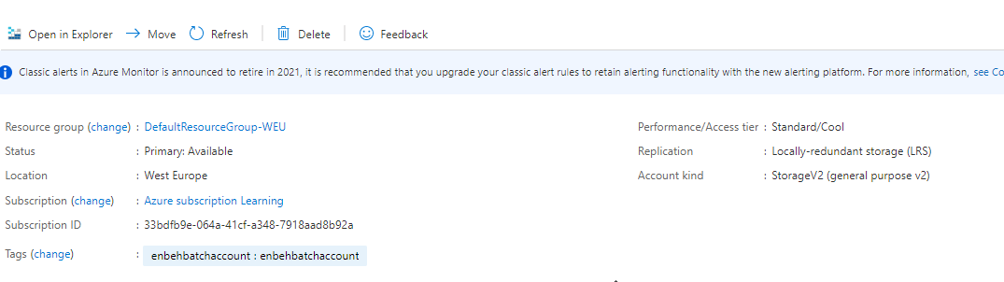

**3-you can change the access tier by click on configuration as below**

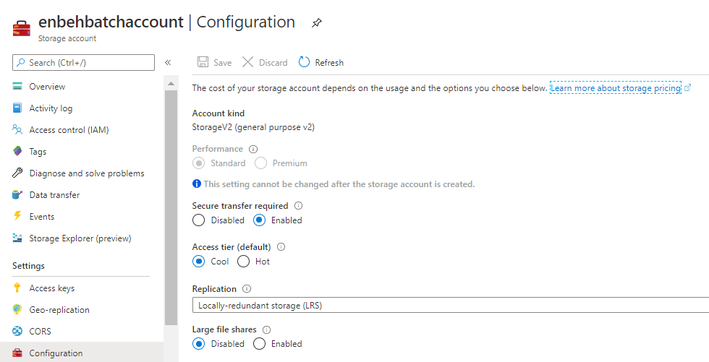

**(so, all blobs inherit the access tier from the storage account)**

**3-on the blob > right click > properities**

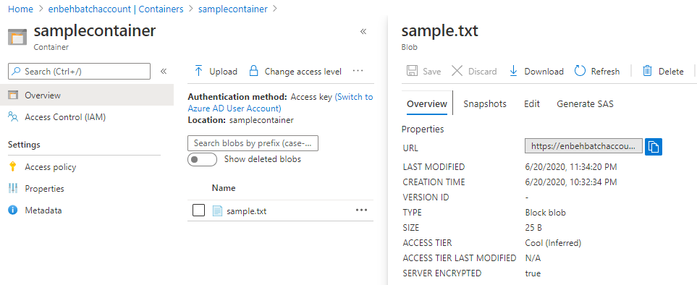

**(in hot and cool access tier you can access and edit the blob at the same time)**

**4-you can change access tier on the blob level**

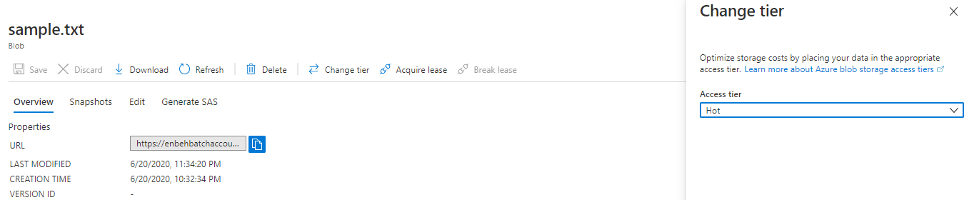

**5-if you change the access tier to archive it take hours to get access to the blob and you cannot edit the blob on the same time**

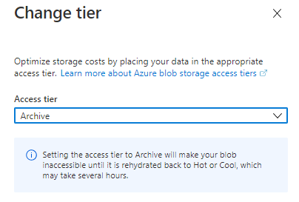

**Steps of apply change on archived file**

